Annexure – III
Staff Profile
To be approved by the Competent Authority of the Affiliating Body
Code No: APS02159

Name of Institution: J.S.P.Sangh’s, Shri Bhimarayappa Fakkirappa Yaligar, College of Education Munavalli

Programme / Course : Bachelor of Education ( B.Ed. )

Address of the Institution: J.S.P.Sangh’s, Shri B.F.Yaligar
College of Education,
At/Po: Munavalli , Tq: Saundatti,
Dist: Belgaum, Pin Code: 591117
S.  No | Name & Designation | Date of Birth | Qualifications |  |  |  |  |  |  |  | Year of  experience  in a recognized secondary | Teaching experience in a Elementary secondary teacher Education Institution from___ to | Date of appoint  ment in the present position | Mode of appoint ment( full time on regular basis/par basis) date of selection committee meeting | Photographs
S.  No | Name & Designation | Date of Birth | General Qualification |  |  | Professional Qualification
S.  No | Name & Designation | Date of Birth | UG/ PG | Subject | (Division/  Percentage  of Marks) | B.Ed/ M.Ed/ Any other | Methodology/ Specialization | (Division/  Percentage  Of Marks) | Research/ other Eligibility test | Subject
1 | Shri Ajjayya Siddayya Amoghimath Principal | 20-5-1974 | B.A  M.A | Kan  Soci.  Ling  Kan | 64.00  57.00 | B.Ed  M.Ed | Kan & Hist  Mngt & EPF | 82.00  58.50 | M.Phil | Edn. | 5 Years | 10 Years | 1/1/2005 | Full Time basis | 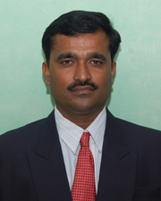
2 | Miss. Gurushantavva  Virupaxappa  Hadapad  Perspectives in Education | 22/7/1981 | B.A  M.A | Hist  Geo  Pol.Sc  Hist | 76.00  52.50 | B.Ed  M.Ed | Hist & Geo  Edn. Tech | 75.00  78.90 | -------- | -------- | -------- | 8 Year | 5/6/2006 | Full Time basis | 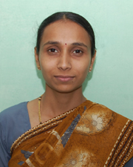
3 | Shri.Fakkeerappa Basappa  Bhovi  Perspectives in Education | 1/7/1974 | B,A  M.A | Hist  Pol.Sc  Soci  Hist | 65.00  62.00 | B.Ed  M.Ed | Hist & Geo  Mngt | 78.00  62.00 | SLET | Edn | 3 Years | 10 Years | 15-1-2005 | Full Time basis | 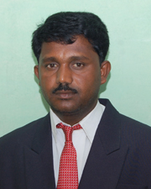
4 | Shri. Neelappa Laxmappa  Kalli  Perspectives in Education | 1-6-1984 | B.A  M.A | Eng  Hist  Pol.Sc  Eng | 63.17  46.66 | B.Ed  M.Ed | Eng & Hist  Teach. Edn | 80.40  79.82 | M.Phil SLET  (Ph.D Reg) | Edn | ------- | 7 Year | 14/7/2008 | Full Time basis | 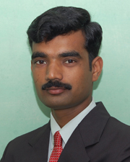
5 | Miss Jayashree Kallappa  Badiger  Perspectives in Education | 21/3/1976 | B.A  M.A | Hist  Pol.Sc  Soci  Hist | 64.88  65.12 | B.Ed  M.Ed | Kan & Hist  Guidance & Council | 75.00  73.00 | M.Phil  SLET  (Ph.D Reg) | Edn | -------- | 7 Years | 1/9/2008 | Full Time basis | 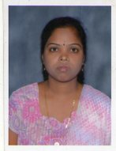
Teaching Staff
6 | Shri Ameet  Appanna  Abbar  Pedagogy | 09/04/1981 | B.A  M.A | Hist  Eng  Pol.Sc  Eng | 54.76  48.52 | B.Ed  M.Ed | Eng & Hist  Mngt & EPF | 74.96  74.00 | ------- | ------- | ------- | 4 Year | 1/1/2011 | Full Time basis | 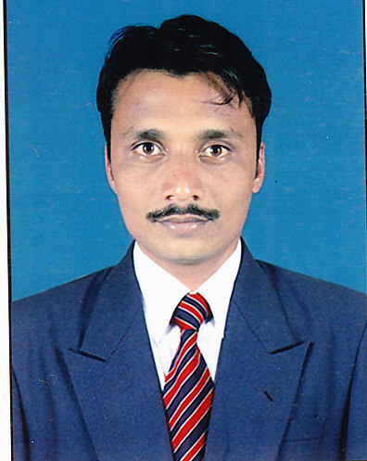
7 | Shri Manjunath Rudrappa Metagudd Pedagogy | 28/05/1990 | B.Sc  M.Sc (Pre) | CBZ  Botany | 64.94  75.00 | B.Ed  M.Ed | Phy.Sc  Bio.Sc  Mngt & EPF | 80.76  72.24 | ------- | ------- | ------- | 0 | 21/10/ 2015 | Full Time basis | 
8 | Miss Jyoti Somalingappa Viveki  Pedagogy | 03/07/1988 | B.Sc  M.Sc (Pre) | PCM  Maths | 70.05  71.00 | B.Ed  M.Ed | Maths Phy.Sc  Psy. | 85.03  74.23 | ------- | ------- | ------- | 0 | 21/10/ 2015 | Full Time basis | 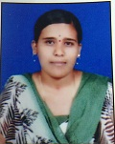
9 | Miss Pushpa Mahaveer Myakalamaradi Pedagogy | 11/03/1978 | B.Sc  M.Sc | PCM  Maths | 76.36  83.37 | B.Ed  M.Ed | Maths Phy.Sc  Mngt & EPF | 81.03  73.66 | ------- | ------- | ------- | 0 | 21/10/ 2015 | Full Time basis | 
10 | Shri Sivanand Nagappa Tigadi Pedagogy | 01/06/1973 | B.A  M.A | Kan  Hist  Soci  Kan | 56.94  59.70 | B.Ed  M.Ed | Kan & Hist  Guidance & Council | 83.20  75.00 | ------- | ------- | ------- | 0 | 21/10/ 2015 | Full Time basis | 
11 | Smt. Sangeeta Basayya Mathapati Pedagogy | 17/05/1984 | B.A  M.A | Hindi  Kan Hist  Hindi | 59.23  55.00 | B.Ed  M.Ed | Hindi  Hist  Mngt & EPF | 72.00  74.23 | ------- | ------- | ------- | 0 | 21/10/ 2015 | Full Time basis | 
12 | Shri Basavaraj Panchappa Gundlur Pedagogy | 01/06/1986 | B.A  M.A | Hist  Eng  Plo.Sc  Eng | 68.92  49.00 | B.Ed  M.Ed | Eng & Hist  Mngt & EPF | 74.66  67.25 | ------- | ------- | ------- | 0 | 21/10/ 2015 | Full Time basis | 
13 | Shri Vasant Siddanna Yaragatti Pedagogy | 22/07/1987 | B.A  M.A | Hist  Eng  Pol.Sc  Pol.Sc | 55.11  64.03 | B.Ed  M.Ed | Eng & Hist  Mngt & EPF | 79.81  74.08 | ------- | ------- | ------- | 0 | 21/10/ 2015 | Full Time basis | 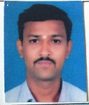
14 | Shri Mahesh Shripatirao Kadam  H & P E | 01/12/1983 | B.A | Soci  Hist  Edn | 56.94 | B.P.Ed  M.P.  Ed | Phy.Edn | 75.53  68.42 | ------- | ------- | ------- | 0 | 21/10/ 2015 | Full Time basis | 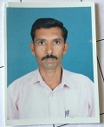
15 | Shri Somanagouda Basanagouda Hiralingannavar  Fine Arts | 01/09/1967 | AM |  | 61.33 | ------- | ------- | ------- | ------- | ------- | ------- | 0 | 21/10/ 2015 | Full Time basis | 
16 | Smt. Anupama Ramanna Bennur  Performing Arts | 31/08/1987 | M.A Music | Music | 60.06 | ------- | ------- | ------- | ------- | ------- | ------- | 0 | 21/10/ 2015 | Full Time basis | 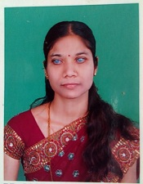

Administrative and Professional Staff
S.  No | Name & Designation | Category | Date of Birth & Age | Qualifications |  |  |  | Year of  experience  in a recognized secondary | Teaching experience in a Elementary secondary teacher Education Institution from___ to | Date of appoint  ment in the present position | Mode of appoint ment( full time on regular basis/par basis) date of selection committee meeting | Photographs
 |  |  |  | General Qualifi-  cation | (Division/  Percentage  of Marks) | Profess-  ional  Qualifi-  cation | (Division/  Percentage  Of Marks)

1 | Shri Laxmikant Gurappa  Tyapi  F.D.A | OBC | 22-7-1975 | B.Com  M.Com. | 48.00  58.00 | ----- | -------- | 17 Years | ------- | 1/12/2004 | Full Time basis | 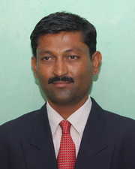
2. | Smt.Akkamahadevi Guranagouda  Patil  Librarian | OBC | 23/9/1969 | B.Sc.  B.Lib  M.L.I.S | 72.00  60.00  63.44 | ------ | -------- | 11 Years | ------- | 1/12/2004 | Full Time basis | 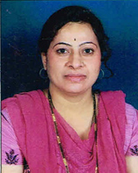
3. | Shri. Prakash Hanamant  Koppad  Library Attendant | OBC | 1/6/1977 | PUC  B.A  B.L.I.S | 64.33  66.00  52.37 | ------ | ------- | 11 Years | ------- | 1/12/2004 | Full Time basis | 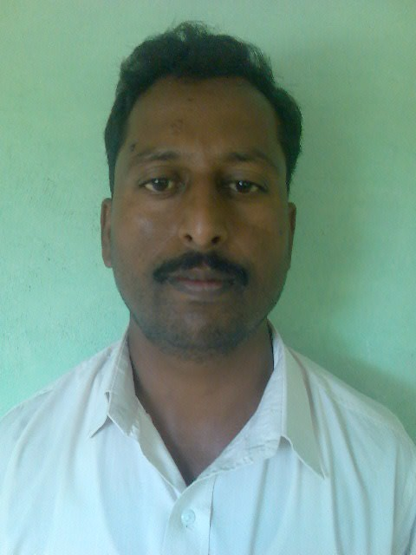
4. | Shri. Arjun Shivanappa  Patil  Attendant | ST | 1/7/1978 | S.S.L.C |  | ------- | ------- | 11 Years | ------- | 1/12/2004 | Full Time basis | 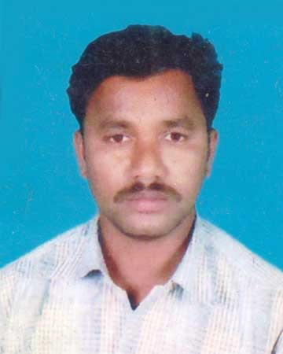
5 | Rangappa  Bhimappa  Tigalannavar  Attendant | ST | 8/6/1987 | SSLC  PUC | 35.04  39.33 | ----- | ----- | 05 Years | ____ | 21/9/2015 | Full Time Basis | 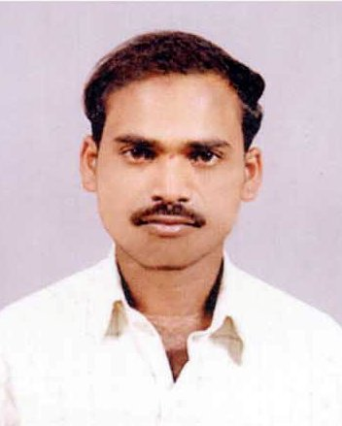
6 | Anandappa Bheemappa  Ullagaddi  Attendant | OBC | 2/6/1972 | SSLC | 48.00 | ----- | ----- | 05 Years | ------ | 21/9/2015 | Full Time basis | 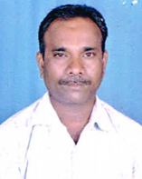
7 | Maruti  Hanamantappa  Deshanur  Attendant | SC | 12/11/1961 | SSLC  PUC | 43.66  35.50 | ----- | ----- | 0 | ------ | 21/9/2015 | Full Time basis | 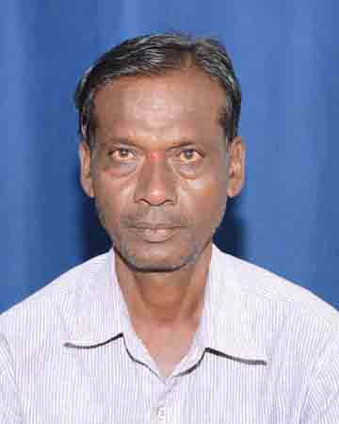
8. | Umesh Balappa Goudar  Attendant | SC | 1/6/1983 | 6th std | 38.10 | ----- | ----- | 0 | ------ | 21/9/2015 | Full Time basis | 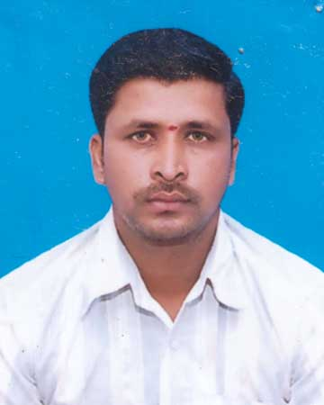

Signature of the Registrar / Director SCERT: ___________________________ Signature of Principal _________________________________

Name of University / SCERT: Rani Channamma University Belagavi Name : Shri A S. Amoghimath

Stamp of University / SCERT: Stamp of Institution

